We are pleased to announce a fully online version of:
Building Trades Academy 107: Multi-Craft Core Curriculum (MC3) Online Train-the-Trainer for Coordinators and Instructors schedule.
This class (offered via Zoom) prepares prospective instructors to teach the MC3.
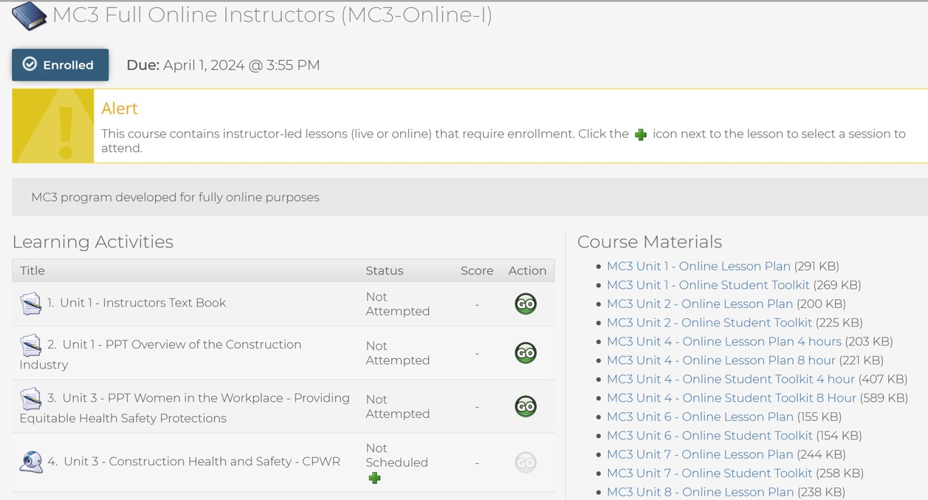
Online MC3 Train-the-Trainer 2026

January 7-8 & 21-22, February 4-5 & 18-19, March 5-6 & 18-19, April 1-2 & 15-16, May 6-7 & 20-21, June 3-4 & 17-18, July 1-2 & 15-16, August 5-6 & 19-20, September 2-3 & 16-17, October 7-8 & 21-22, November 4-5 & 18-19, December 2-3 & 16-17.

12:00PM- 3:30PMEST
Full-group sessions will meet on both days of the training. Small-group and individual work must be completed before the start of whole-group instruction each day. Assignments, readings, and registration information will be distributed to registered participants during the week prior to the training.

Please note: Sessions with fewer than five participants may be subject to cancellation. Previously registered participants will be transferred to the next available training. All participants must have prior approval from their local Building Trades Council to enroll in this class.

To enroll, please contact program@tradesfutures.org.

Updated 5.7.2026.

